

Foundations of Programming

Assignment No.: 18
PROBLEM STATEMENT: Write a C program that accepts a string from the user and performs the following string operations: i) Calculate length of string ii) String reversal iii) Equality check of two strings iv) Check palindrome v) Check substring.

OBJECTIVE:

- To understand basic string operations in C.
- To learn how to manipulate strings using loops and functions.
- To perform comparison, reversal, and substring checking.
- To check whether a string is a palindrome.

THEORY:
In C programming, a string is a sequence of characters terminated by a null character ('\0'). Strings are commonly stored in character arrays. Various operations can be performed on strings such as calculating their length, reversing the characters, comparing two strings, checking whether a string is a palindrome, and finding a substring within another string. These operations can be implemented using loops and conditional statements or by using standard library functions from the string.h header file.
PLATFORM: Linux

PROGRAM
#include <stdio.h>
#include <string.h>

// Function to reverse string
void reverseString(char str[]) {
int len = strlen(str);
printf("Reversed String: ");
for(int i = len - 1; i >= 0; i--) {
printf("%c", str[i]);
}
printf("\n");
}

// Function to check palindrome
void checkPalindrome(char str[]) {
int len = strlen(str);
int flag = 1;

for(int i = 0; i < len / 2; i++) {
if(str[i] != str[len - i - 1]) {
flag = 0;
break;
}
}

if(flag)
printf("String is Palindrome\n");
else
printf("String is NOT Palindrome\n");
}

// Function to check substring
void checkSubstring(char str[], char sub[]) {
if(strstr(str, sub) != NULL)
printf("Substring FOUND\n");
else
printf("Substring NOT FOUND\n");
}

int main() {
char str1[100], str2[100], sub[50];

// Input string
printf("Enter a string: ");
gets(str1);

// i) Length
printf("Length of string: %lu\n", strlen(str1));

// ii) Reverse
reverseString(str1);

// iii) Equality check
printf("\nEnter another string for comparison: ");
gets(str2);

if(strcmp(str1, str2) == 0)
printf("Strings are EQUAL\n");
else
printf("Strings are NOT equal\n");

// iv) Palindrome check
checkPalindrome(str1);

// v) Substring check
printf("\nEnter substring to check: ");
gets(sub);

checkSubstring(str1, sub);

return 0;
}
INPUT: A string and another string for comparison and substring checking.

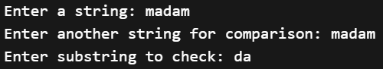

OUTPUT: Displays string length, reversed string, equality result, palindrome result, and substring check result.

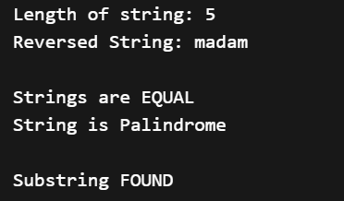

SAMPLE INPUT:

Enter a string: madam
Enter another string for equality check: mad
SAMPLE OUTPUT:
Length of string = 5
Reversed string = madam
The string is a Palindrome
Strings are not equal
Substring found in main string

CONCLUSION: Thus, the C program successfully performs different string operations such as length calculation, reversal, equality check, palindrome check, and substring detection.

FAQs:
- What is a string in C programming?
- Which header file is required for string functions?
- What function is used to find the length of a string?
- What is a palindrome string?
- Which function is used to check a substring in C?

